Object Orientation and UML
Lab 2



Seán, O’Malley
B00150952

Department of Engineering
School of Informatics & Engineering
Institute of Technology, Blanchardstown
Dublin 15.

Software design and quality
24/11/2025
Introduction
In this lab you will practice creating visual models of a problem domain to better understand
the problem before moving onto the Design Phase and defining the software architecture
next week.
In the last lecture we started to discover problem domain concepts that will form the basis
of our software classes later. As you have found, analysis is NOT a trivial task, especially
when done on your own. Requirements analysis and conceptual modelling is a collaborative
exercise

Problem Statement
You have been tasked with designing the software system for a simple weather-station. A
weather station records local weather information and periodically transfers this to a
weather information system using a satellite link. Currently the system keeps track of
temperature, wind speed (Anemometer) and pressure (barometer) but must be flexible
enough to be expanded at a later stage.
The system is composed of a basic Micro-controller, a single temperature sensor, a display,
memory bank and user buttons.
The system displays temperature readings in real time on the display. It also keeps track of
historical information on an hourly and daily basis. This historical data can be pulled up on
the display at the request of the user by pressing the appropriate button.

Use Case Analysis
Use Case Model
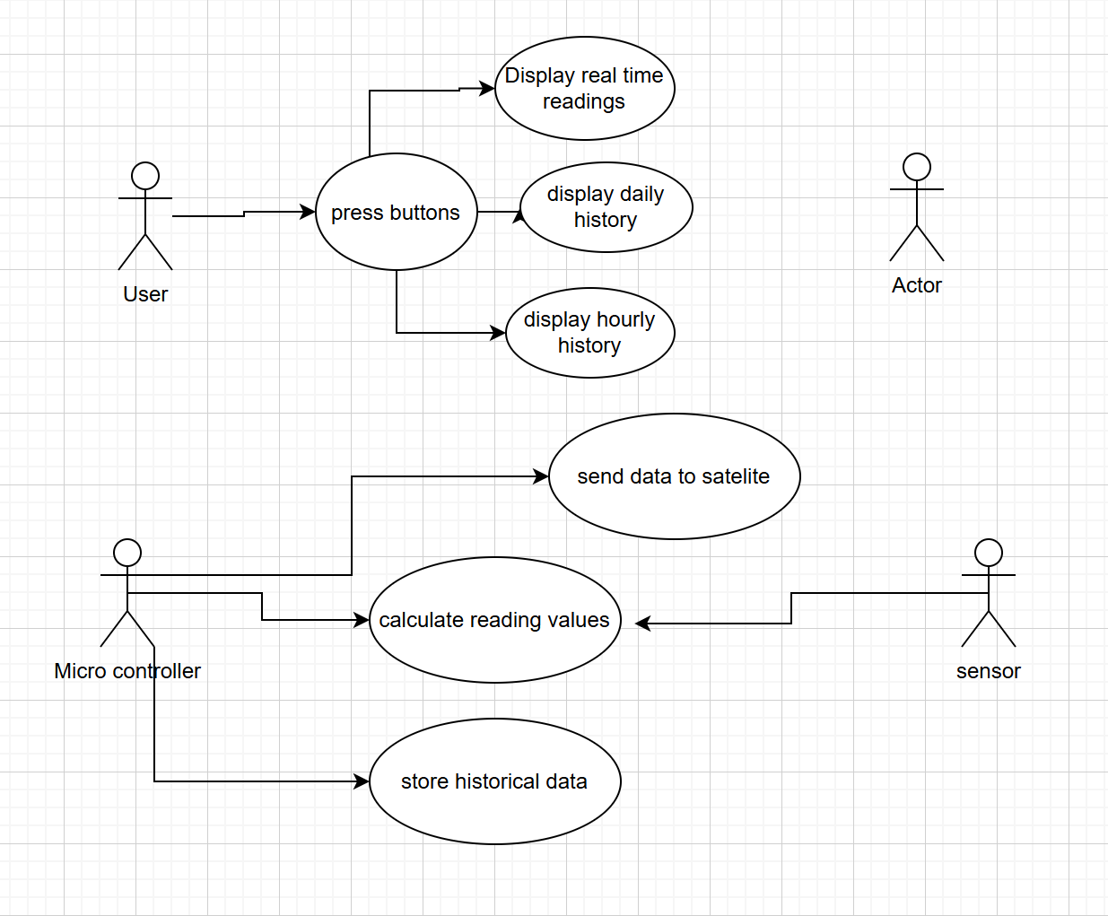
Description
The user initiates actions by pressing one of the buttons. This triggers the system to display the different categories i.e. real time information, daily or hourly history. A sensor gathers raw data and sends it to the microcontroller to be read. The microcontroller will then store the data for future historical reference. The microcontroller then converts the data to human readable numbers. After this, the system will send the data to a satellite for remote monitoring or further data collection.
Actors

Conceptual Model
UML Class Conceptual Model
Modelling Assumptions

Systems Design Observations and Recommendations

